Experiment no.:04 Keerthika.K-241901046
Find Last Connected USB on your system (USB Forensics)
Aim:
To find the last connected USB devices on a system using USBDeview for USB forensics.
Procedure:
- Download and run the USBDeview utility on the Windows system.
- Open USBDeview to view the list of USB devices currently connected to the computer and those previously used.
- Examine the displayed list of USB devices.
- Select a USB device to view its detailed information.
- Observe the device name and description, device type, and serial number, if available.
- Examine the date and time when the USB device was added to the system.
- Note the Vendor ID (VID) and Product ID (PID) displayed for the device.
- Identify the most recently connected USB device by examining the available device information and timestamps.
- Record the relevant USB device details for forensic investigation.
- Save or document the observations for further analysis.
Observation:
USBDeview is a utility used to display information about USB devices currently connected to a computer and devices that were previously used. It provides details such as device name, description, device type, serial number, connection-related date and time, Vendor ID, and Product ID.
The following observations can be recorded:
- The USB devices detected by USBDeview were listed.
- Information about previously connected USB devices was displayed.
- Device names and descriptions could be examined.
- Serial numbers and device identifiers were available for supported devices.
- The recorded date and time information could be used to identify the most recently connected USB device.
Observation Table:
S. No. | Parameter | Observation
1 | Tool Used | USBDeview
2 | Operation | USB Forensics
3 | Device Information | Port_#0001.Hub_#0…  HP USB Flash Drive Usb derive
4 | Device Type | Mass Storage
5 | Serial Number | 070D298AEFF83
6 | Vendor ID (VID) | 03f0
7 | Product ID (PID) | 1985
8 | Connection Date/Time | 11-08-2026 12:28:19
9 | Last Connected USB | 11-08-2026 12:30:31
10 | Status | Safe to unplug

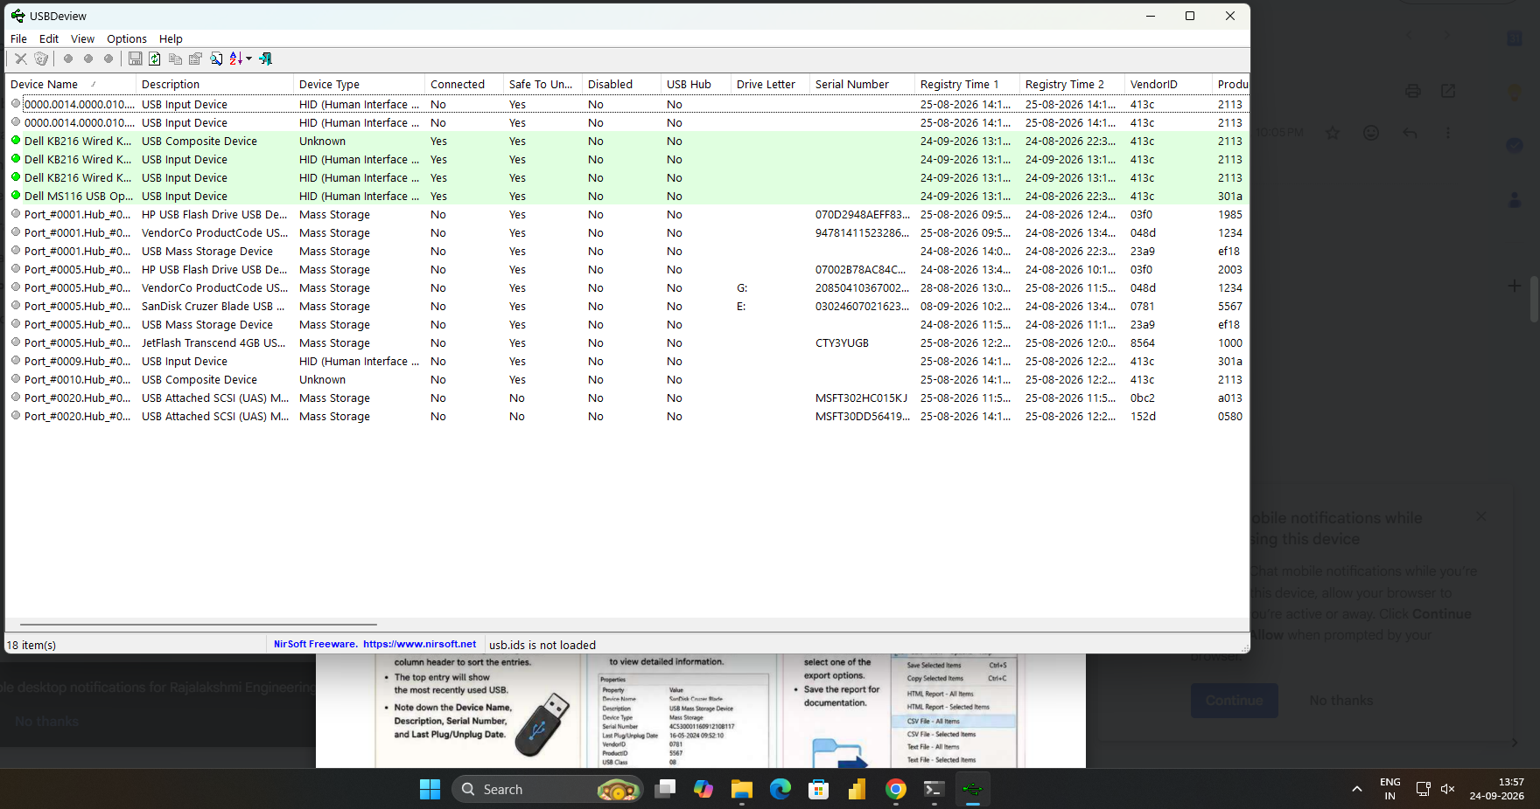
Aim
To collect email evidence from a victim PC using DumpIt and Bulk Extractor Viewer.
Procedure
- Use the DumpIt tool to capture the RAM of the victim PC as the first step in collecting email evidence.
- DumpIt is used to generate a physical memory dump of Windows machines and supports both 32-bit and 64-bit systems.
- Run the DumpIt.exe file.
- Enter Y when prompted to proceed with memory acquisition.
- The raw memory dump file with the .RAW extension will be generated and saved in the same directory.
- Download Bulk Extractor Viewer from GitHub and install it on the system.
- Open Bulk Extractor Viewer and select the option to generate a report.
- Select the memory dump image file created using DumpIt.
- Choose an output folder for the report.
- Click Start Bulk Extractor to begin processing the selected dump file.
- After processing, open email.txt to examine the email addresses identified in the collected data.
- Open email_histogram.txt to examine the email-related histogram information.
- Record the observations for forensic investigation.
Observation
DumpIt generates a raw physical memory dump of a Windows system. Bulk Extractor Viewer processes the dump and generates a report containing extracted information. The files email.txt and email_histogram.txt can be examined to identify email-related evidence present in the processed data.
Observation Table
S. No. | Particulars | Observation
1 | Tool Used for Memory Acquisition | DumpIt
2 | Memory Dump Format | .RAW
3 | Analysis Tool | Bulk Extractor Viewer
4 | Input Evidence | Memory dump file
5 | Output File 1 | email.txt
6 | Output File 2 | email_histogram.txt
7 | Email Evidence | Record the details actually extracted
8 | Status | Record the actual processing result
Result
Thus, the procedure for collecting and examining email-related evidence from a victim PC using DumpIt and Bulk Extractor Viewer was studied.

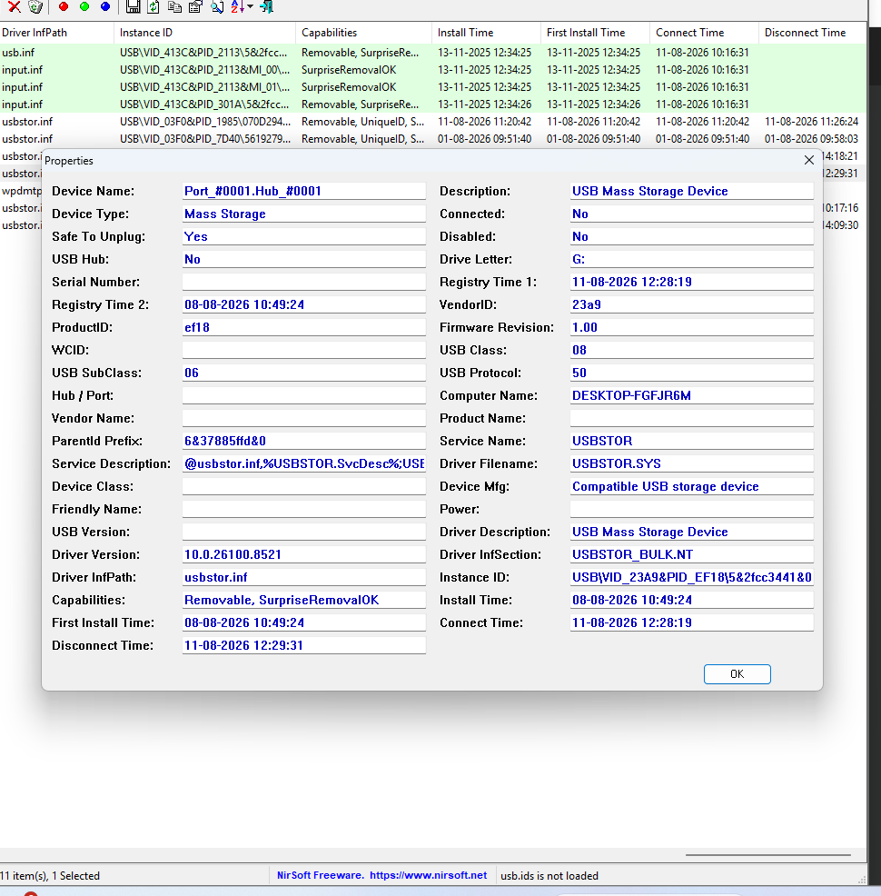

Result:
Thus, USB forensics using USBDeview was studied, and the available information about currently and previously connected USB devices was examined to identify the last connected USB device.

